

MARMARA UNIVERSITY

FACULTY OF ENGINEERING
DEPARTMENT OF COMPUTER ENGINEERING
CSE4082
ARTIFICIAL INTELLIGENCE
ASSIGNMENT 1
-PEG SOLITAIRE-

Emine Çığ 150118012
Ahsen Yağmur Kahyaoğlu 150119788

Introduction
In this project, we implemented a python code for the peg solitaire game. The game is played on a board with 33 holes, with 32 pegs and one empty hole. The goal is to arrange the pegs so that there is just one peg left on the board, which is located in the center hole.
The matrix representation of the board is used in order to keep track of the current state of the game. Each item of the matrix represents a hole on the board, with a value of “0” representing an empty hole and a value of “1” representing a peg. In this assignment we used number of search algorithms. These are breadth-first search (BFS), depth-first search (DFS), iterative deepening search (IDS), depth-first search with random selection (DFS_R) and depth first search with a node selection heuristic. These algorithms are used to find a solution to the peg solitaire game by exploring the space of possible moves and searching for a goal state.
The Node class that defines a state in the search space is implemented. Each Node object stores the row and column of the empty hole, the current state of the matrix, the depth of the node in the search tree, and the parent of the node. The Node class also includes a method for calculating the Manhattan distance, which is used as a heuristic in depth first search with a node selection heuristic.
The functions that being used are as follows;
- removeFrontier Method

This function removes a node from frontier according to the search algorithm being used. If it is BFS it removes from the top, the other search methods use DFS logic, because of that the other algorithms remove from the end.

- isFrontierEmpty Method

This function checks if the frontier is empty by looking length of the frontier list. If the length is 0 the function returns True, otherwise returns False.

- isGoalState Method

This function checks if the current matrix has 1 remaining in the center of the board. (17th index node)

- isTimeLimitExceeded Method

This function returns True if the time limit has been exceeded and False otherwise. The limit is 60 minutes. Time spent is calculated by subtracting initial time from current time.

- getPath Method

This function prints the solution path from the final node.

- printCurrentMatrix Method

This function prints the current state of the board as a matrix. It prints the empty holes as a “0”, pegs as a “x” and the unused nodes as a blank space.

- getZeroValueCoordinates Method

This function returns and inserts to zeroValueCoordinates list index of the empty holes as a tuple.

- collectOrderedAccessibleNodesList Method
This function collects the accessible nodes around the empty holes and extend the nodes list.
- getAccessibleNodes Method

This function gets the accessible nodes around the current node by checking every direction, then adds them to the list to return.

- checkAccessiblity Method

This function checks every 2 nodes around the current node according to its direction. If it finds a valid direction to move creates a node.

- countRemainPegs Method

This function counts the remaining pegs of the current matrix and returns the count.

- calculateManhattanDistance Method

This function holds a remaining pegs list and calculates the sum of Manhattan distances of these pegs to the center hole. Then, divides the sum to the number of remaining pegs.

- search Method

This function applies search algorithms according to search type selection. The search algorithms except the iterative deepening search are implemented in this function because of the depth limit restriction. In order to search for BFS, DFS, DFS with random and DFS with heuristic node selection a while loop created. This loop runs until the frontier list empty and the time limit exceeded. To remove node from frontier list according to search type the “removeFrontier” function is used. After removing node from frontier number of expanded nodes are incremented by 1. In addition, to find the best sub-optimal solution, remaining pegs are compared to best solution.

The breadth-first search algorithm visits each node of the tree level by level and it uses FIFO principle (first in first out). On the other hand, depth-first search algorithm searches deepest node first, and if no children are found for that node, the search proceeds to its parent node. It uses LIFO principle (last in first out). To differentiate these search algorithms there is an if statement that checks the order of nodes list. The node list ascending in BFS and descending in DFS. In the DFS random, order of nodes list is shuffled. Moreover, for DFS heuristic node selection search the Manhattan distance method is used. The Manhattan distance is the sum of absolute difference between the measures in all dimensions of two points. In order to measure “calculateManhattanDistance” function is used. After the calculation, nodes list is sorted according to Manhattan distance in descending order. For BFS and DFS nodes list sorted according to indexes. If the function finds the goal state it returns true and updates the number of optimal solution pegs, otherwise it continues to append the nodes to frontier list. When the frontier list larger than the maximum number of nodes in memory, it will be updated by frontier list.

- IDS Method (Iterative Deepening Search)

The search algorithm is created on separated function due to include a depth iteration from zero to infinite, until time or memory limit exceeded. It calls for each depth limited search which is a depth first search limited by depth level. It does not visit children of expanded node after this depth value. If the solution is middle side of the problem, it can be found faster with this algorithm. Normal DFS algorithm visits the left side of the tree deeply for our problem to select node which has smaller index between possible nodes for an expanded node state. For each depth iteration, frontier will be created again before the first node is assigned to it. Inside the current depth level, normal depth first search is performed. Expands last node from the frontier, gets the accessible movement states on nodes array, checks goal state for each movement, updates current sub optimal solution variables. Depth first search approach needs to pop nodes array from the end which is accessible movement node list. It has to be sorted from largest to smallest before adding to the frontier to select smaller index child first. Maximum number of nodes on memory is updated if the new frontier has bigger size. For each remove frontier operation, a counter is incremented by 1 to obtain “numberOfNodesExpanded”. For each depth level, these operations are repeated. After the loop ends, function returns best Sub Optimal Solution Node, best Suboptimal Solution Pegs, number Of Nodes Expanded, maximum number of nodes in memory.

- menu Method

This function prints the menu of search types. The input given by the user. User enters the selected numbers to run the search algorithms. If the user enters invalid input, function gives an error and returns the menu. IDS function is separated from the search method; therefore, the function uses try-except solution. If search type is IDS the function calls “IDS” function, otherwise calls the “search” function. Checks whether the memory is full or not. At the end of the function, it prints the name of executed search algorithm, time limit, time spent of execution, number of nodes expanded and the maximum number of nodes in memory. If the goal state could not be found, function prints the best suboptimal solution. Finally, prints the number of remaining pegs in the board and prints the path of best suboptimal solution.
Console output of the program for the menu
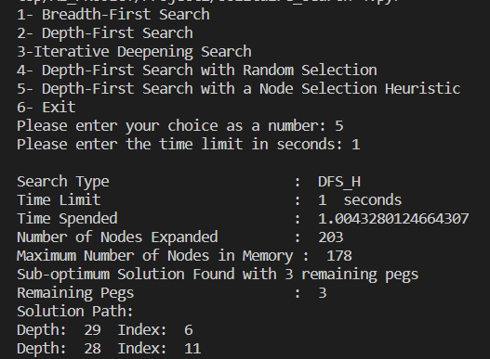

Outputs
- Breadth-First Search Algorithm

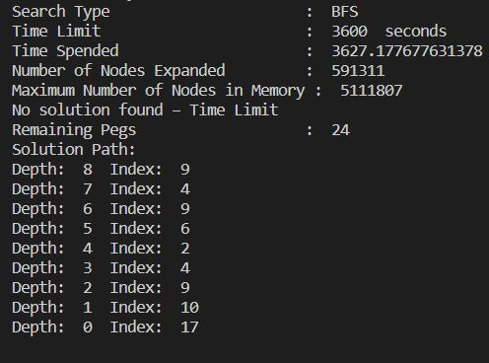

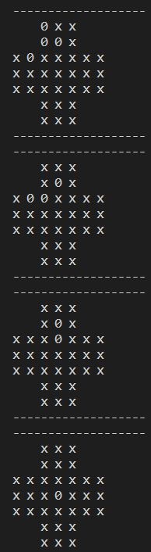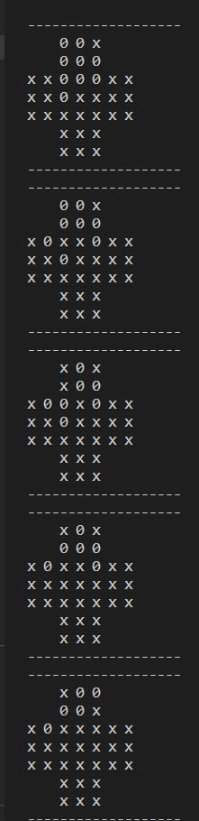

- Depth-First Search Algorithm
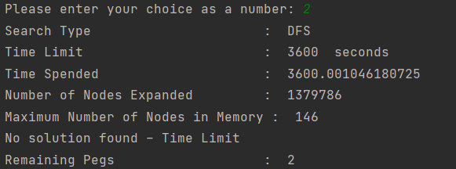
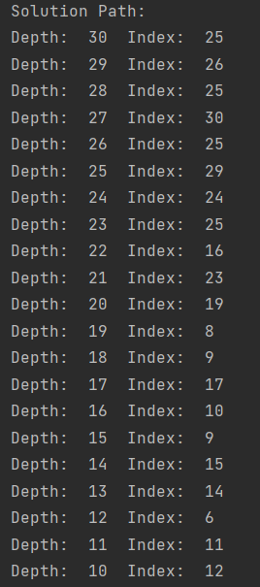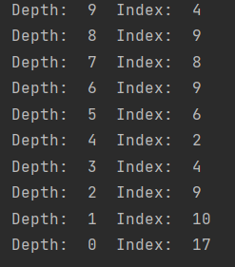

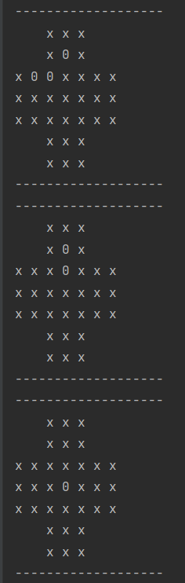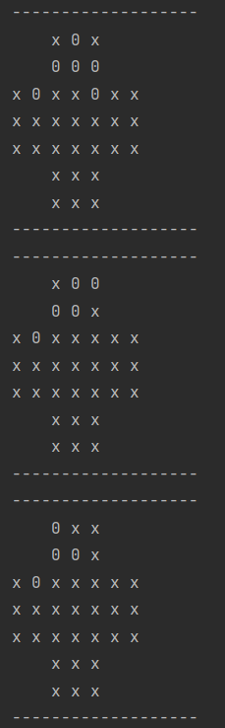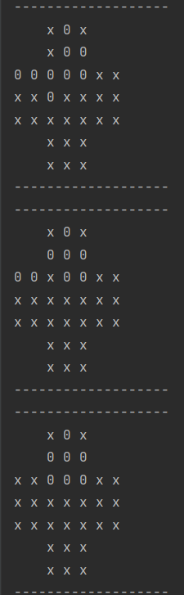
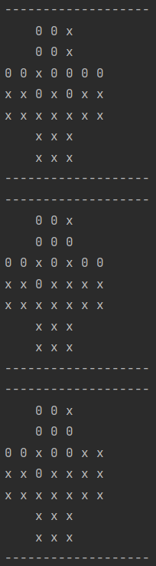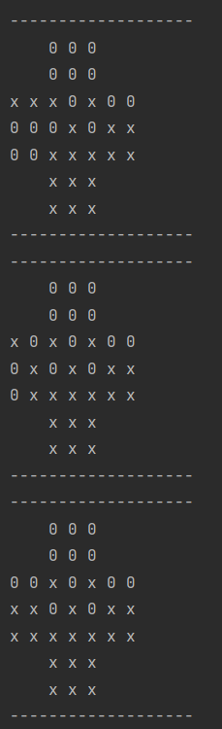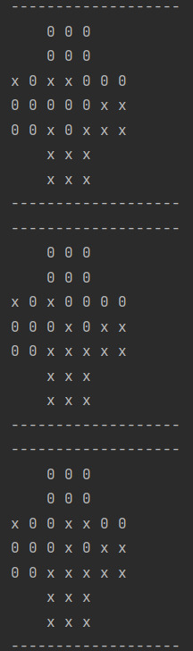

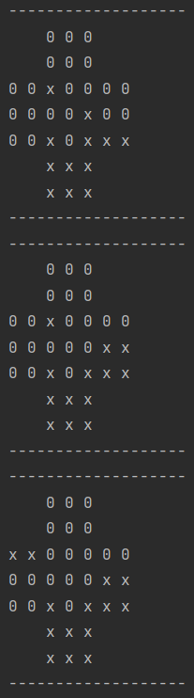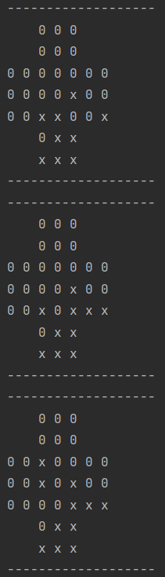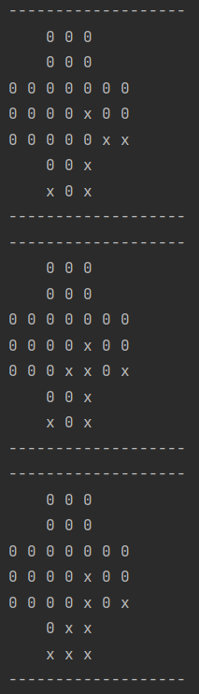
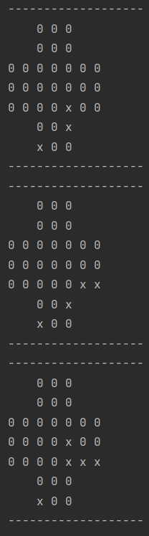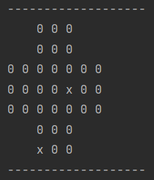
- Iterative Deepening Search Algorithm

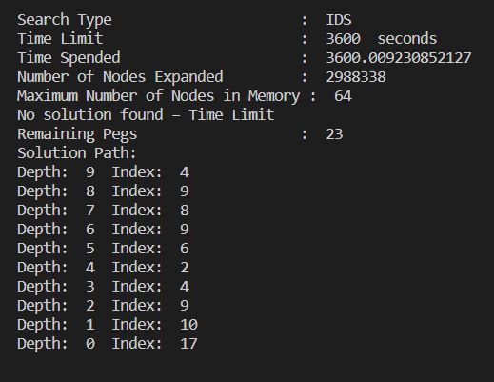
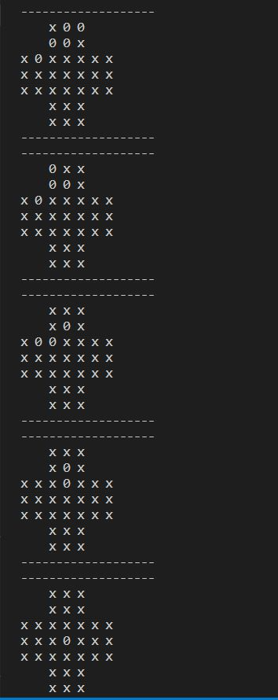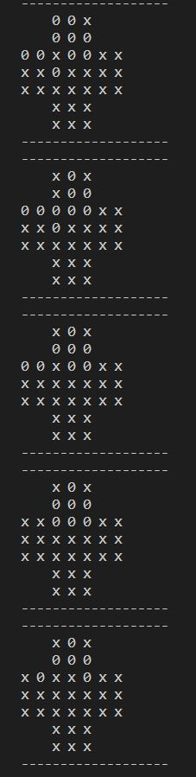
- Depth-First Search Random Node Selection

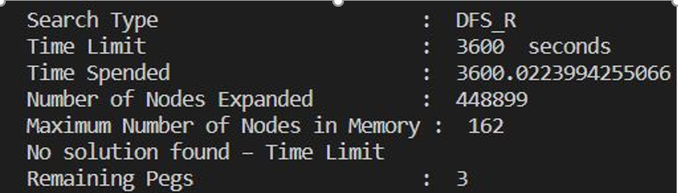

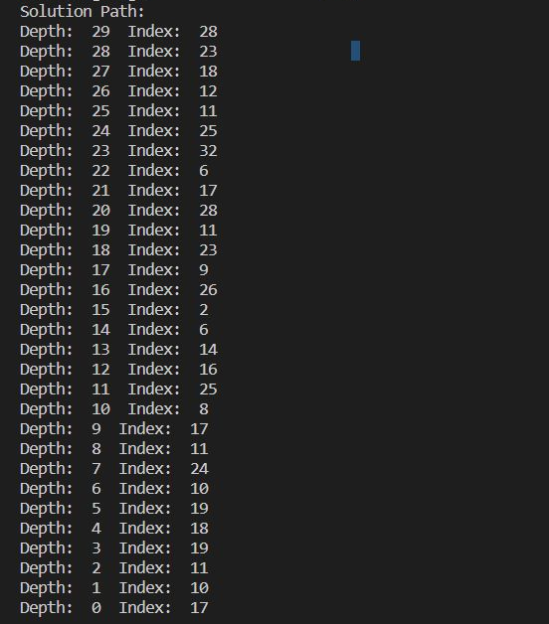

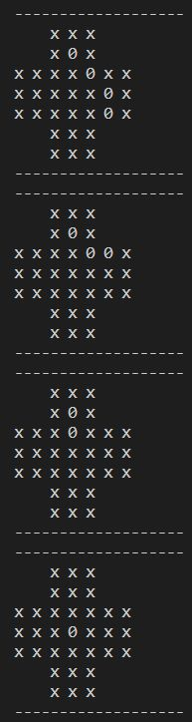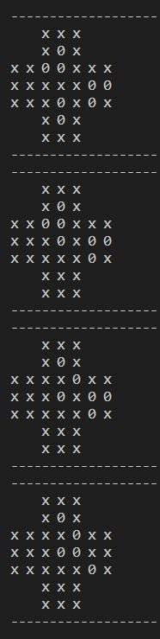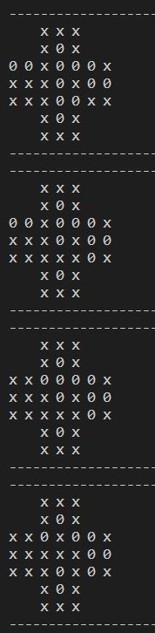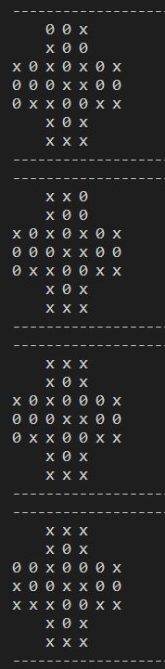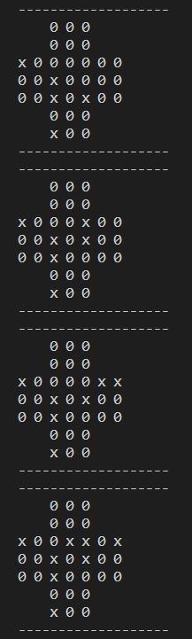
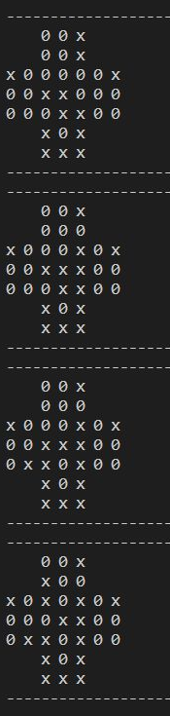 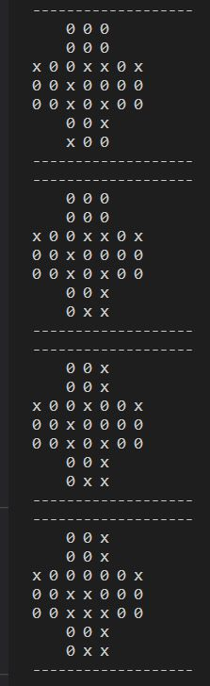,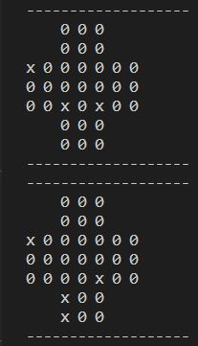

- Depth-First Search with Node Selection Heuristic

